Robert Minson

ITT-116

January 26, 2022

Prof. Reed

Network Configuration

1. On the virtual machine there are only two connections available to it. One being to the host machine and one being to the ISP 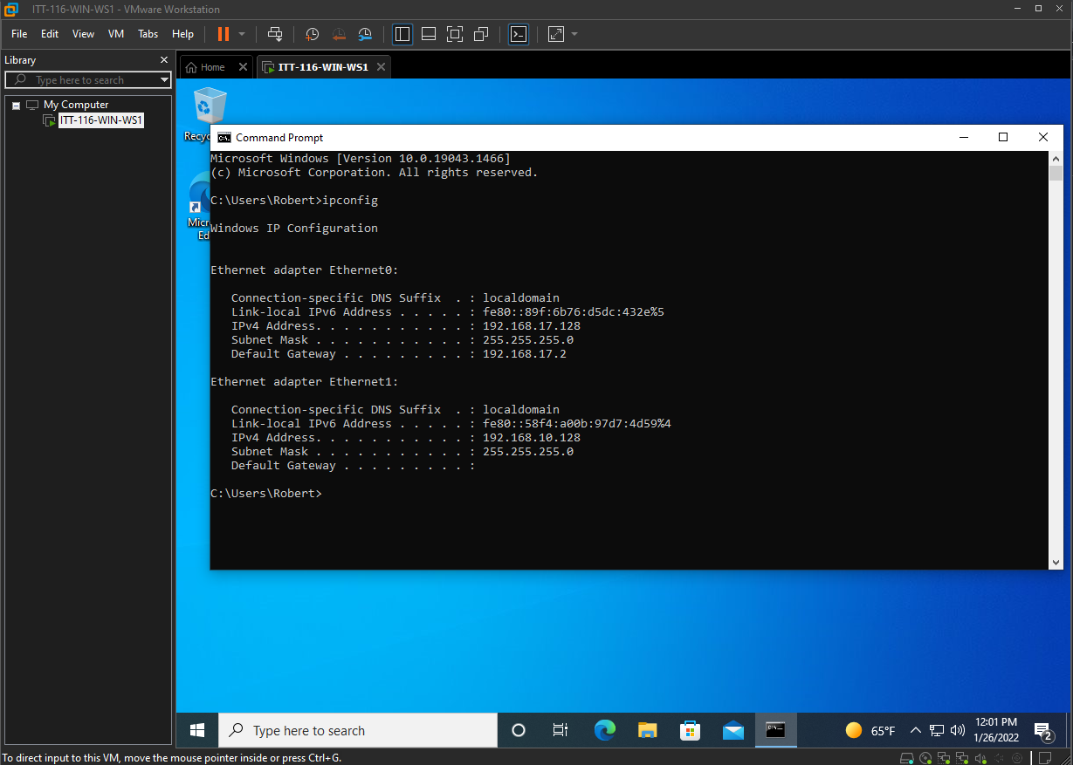
2. The one used by the VM to connect to the host machine is Ethernet0. 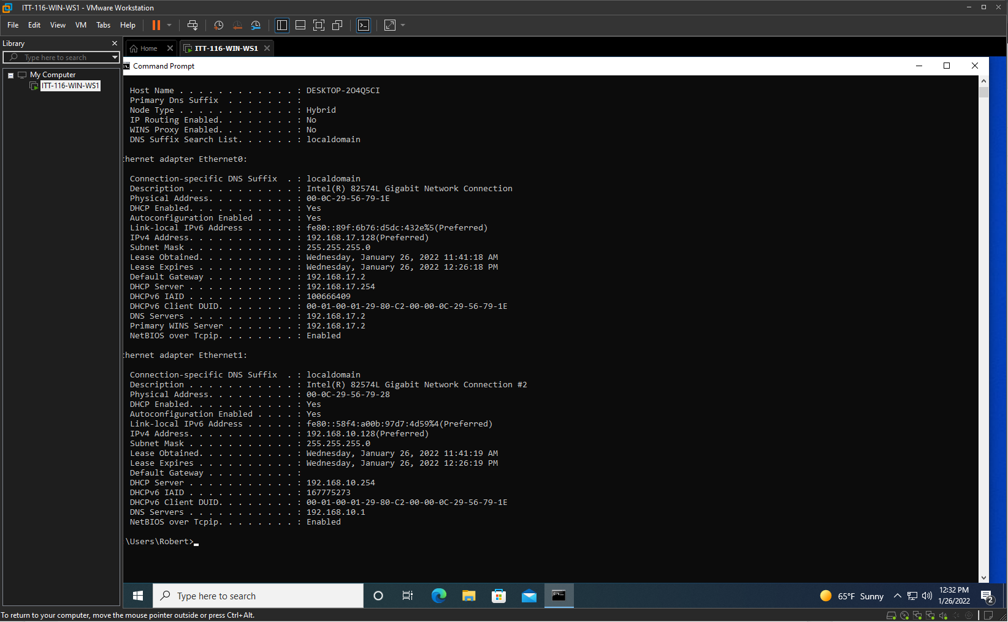
3. The difference between the host and virtual machines are that the host has its own hardware that it runs off and is directly connected to a network. While the virtual machine has no hardware of its own, having to use the host system’s, and it has to go through the host system to access other networks outside of the two machines.
4. To isolate the virtual machine, you first need to go into its setting on the OS you are using to run it. From there, locate the network adapter
5. The IP address of the system is 192.168.10.128A screenshot of a computer

   Description automatically generated
6. The IP address of the host system is 137.152.89.1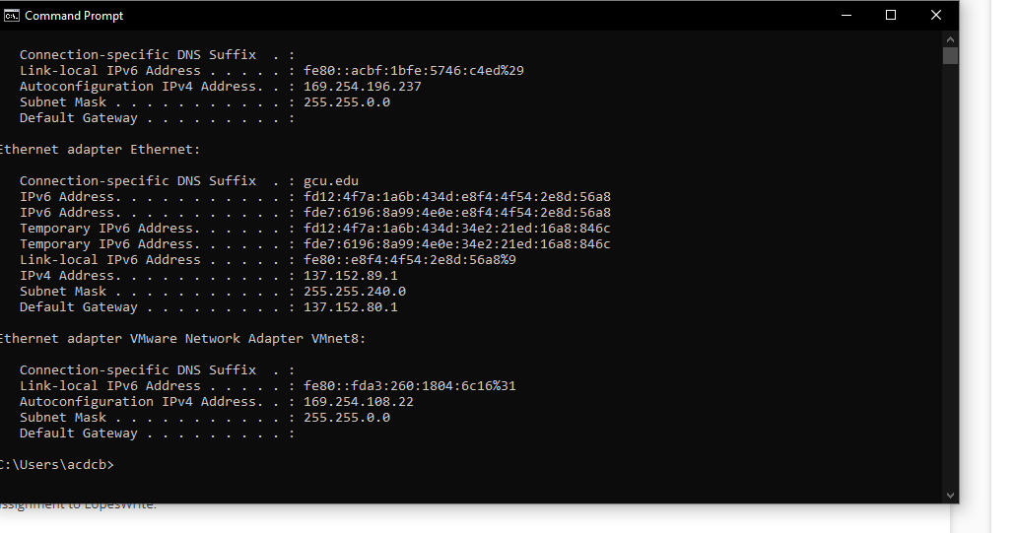
7. The other address for each system are as follows, 

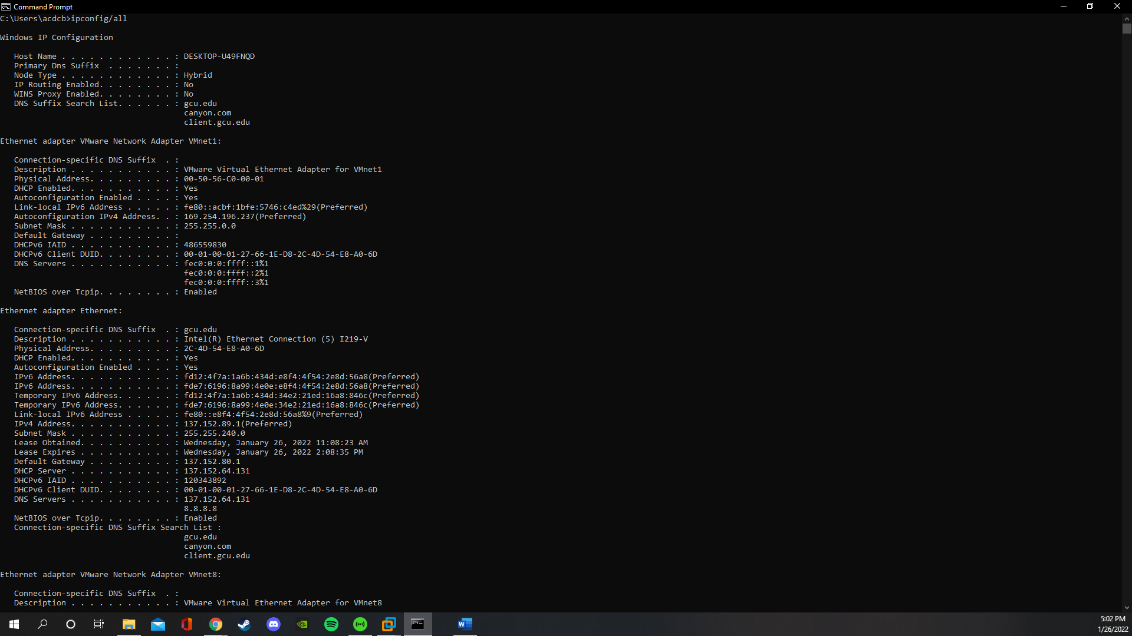

1. A DNS, domain name server, is a way to translate domain names into IP addresses. Without the use of a DNS, people would have to remember the IP address for each site that you visit online. A DHCP, dynamic host configuration protocol, is what allows your machine to give out its IP address and access other IP addresses that you might need. It can also provide other information “such as the subnet mask and default gateway” (Dknappettmsft, 2021).
2. A MAC address is the address that comes with the NIC, network interface card, that is in your machine. You only get one MAC address per NIC however things like and ethernet port and Wi-Fi, you will have 2 MAC addresses. The MAC addresses of the VM are 00-0C-29-56-79-1E and 00-0c-29-56-79-28. The MAC address of the host machine is 2C-4D-54-E8-A0-6D. 



References

Dknappettmsft. Eross-msft. Iangpgh. Jamesmci. JasonGerend. Khdownie. (2021, July 29). *Dynamic host configuration protocol.* Microsoft.<https://docs.microsoft.com/en-us/windows-server/networking/technologies/dhcp/dhcp-top>

*Technology services.* (2021, January 16). The Ohio State University. <https://slts.osu.edu/articles/whats-a-mac-address-and-how-do-i-find-it/>

*What is DNS how DNS works.* (n.d). CloudFlair. <https://www.cloudflare.com/learning/dns/what-is-dns/>